**Case Study – 8  
(50 points)**

**Name: Patrick Woodrum**

**Clemson ID: C79975506**

**Submission**: Save this Word document with your answers as a PDF file and upload the PDF file to Canvas.

(40 pts) Create 4 UI Mockups/Wireframes for the Book Exchange Project with data validation constraints indicated. These **must** be more than simple logon screens! You can use one of the diagramming tools identified on the “External Tools Page” in Canvas or one of your own choosing.

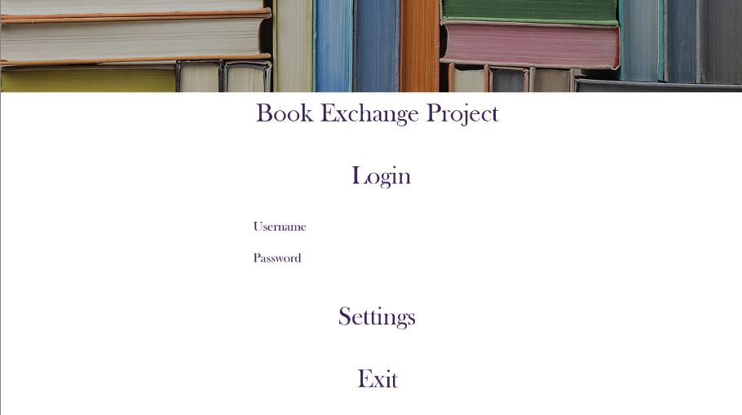

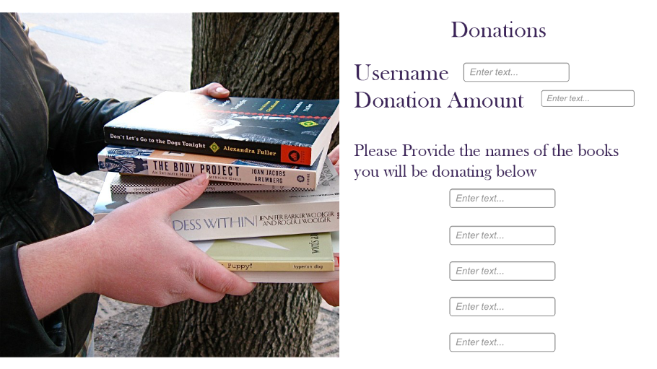

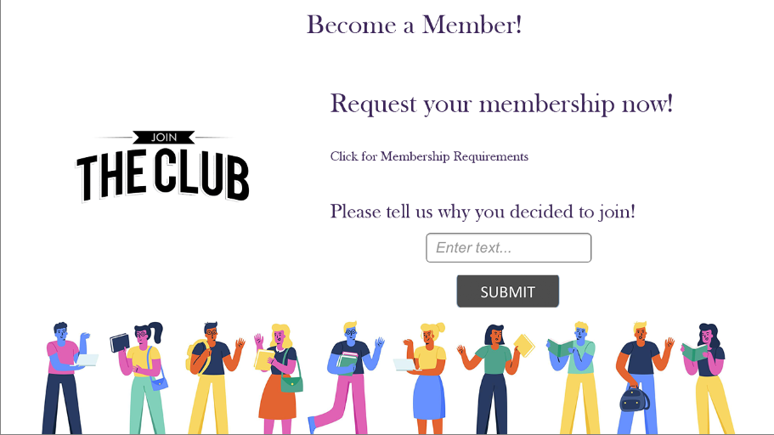

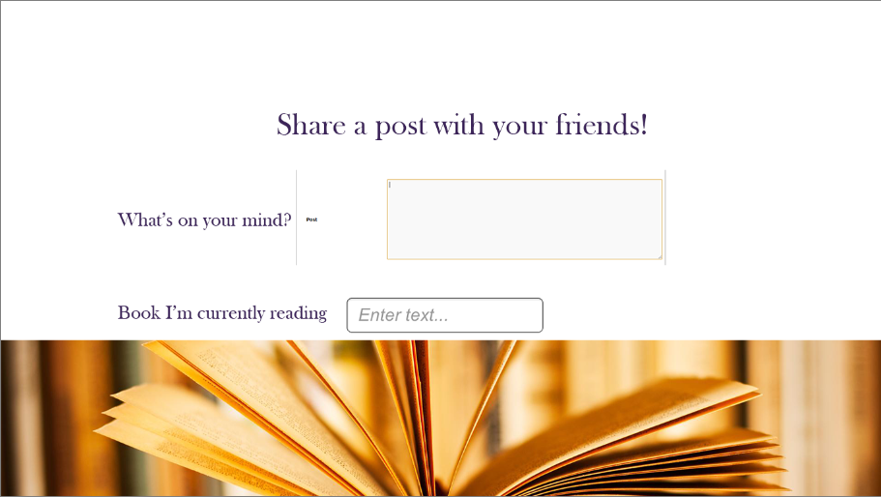

(10 pts) Create 2 report mockups for the Book Exchange Project, keeping in mind the guidance in Fig 8.14. Use one of the diagramming tools identified on the “External Tools Page” in Canvas.

